Name:

Class ID:

Class Hour:

Chapter 5 -Work Related Forms and Laws

**Student Activity Packet**: This packet is worth 20 points and is handed in at the end of the unit. It is used to complete some assignments along with fill in notes throughout the unit. Reminder that all daily plans, notes, and assignments are posted on-line and can be completed at [www.marketingmps.com](http://www.marketingmps.com) if you are absent.

Lesson 5 – 1 Objectives:

* What are withholdings
* Who must pay taxes and how are my taxes paid
* Required Work forms needed for employment

# Two Types of Pay and Withholding

**Gross wage:**

**Net Wage**:

**Withholding**: Also known as is defined as

Money is used to pay for:

How do you pay taxes?

Who pays taxes?

Most people owe taxes on . The more you the more you in taxes. Some people are from paying taxes. This means they don’t owe taxes. The following people do not owe taxes: **Standard Deductions**: Use the Internet and answer the following questions:

1. What is a Standard Deduction?

1. How Much is the Standard Deduction in 2021 if you are single?

The best way to describe a Standard deduction is: The first If you are single is not taxed. Employees do not pay taxes to the government directly unless they are . E withhold this from your wages/salaries before you get your check and pay it to the IRS for you. This is called . Most likely in high school you will earn under the standard deduction and owe .

Why are taxes withheld if you don’t earn more than the standard deduction?

The US is on a progressive Tax System:

The first  *of your income is taxed at %*

The next amount of of your income is taxed at %

What amount is taxed at 37%

## Forms needed in employment:

1

2

3

4

# W4 Form:

W4 Form (definition):

Key Facts:

Dependents (definition):

# Social Security Form

Social Security Card (definition):

This card can be used for

For security of your card, do not give it out on , , or . If you need a new card you can go to two locations, any local S , or get an application . You will need to provide proof of   
 and proof of . If you order online, you must mail the original copies of your proof along with the application. It will be mailed back to your along with the new card within  
 .

# Payroll Taxes:

Define Payroll Taxes:

Five types of Taxes that can be withheld: enter the type and the definition:

1

2

3

4

5

Which of the two are called FICA Taxes or part of the FICA Act and are given back when you are elderly?

FICA Taxes: Complete the notes from the Tax Tutorial presentation notes on the class webpage.

|  |  |  |  |
| --- | --- | --- | --- |
|  | % paid by Employee | % paid by Employer | Benefits Provided |
| Social Security Tax: |  |  |  |
| Medicare Tax: |  |  |  |

Example: If you earned gross wage of $1500 for two weeks. What are the following:

Employee Contribution Social Security: Employer:

Employee Contribution Medicare: Employer:

Total Employee Contribution to Payroll Taxes: Total Employer:

What is the total amount sent to the government in your name for FICA Tax?

Other Withholding Amounts from your Check – optional benefits employees elect to have withheld:



Calculate the following Net Wage: You work for $2000 gross pay for the two-week period. Your federal income tax is $225 and you have $100 withheld and put into a 401 K. There is no state or local tax where you live. What is your net income after you calculate the FICA taxes?

Gross:   
Federal Income Tax   
Social Security   
Medicare   
Retirement   
Total Net Wage:

Chapter 5, Work Related Forms and Laws, Section 5 - 1 – Work Related

Key Facts:

I9 Forms

When is it completed, how often, and for what purpose?

W2 Forms

Key Facts:

When is it completed, how often, and for what purpose?

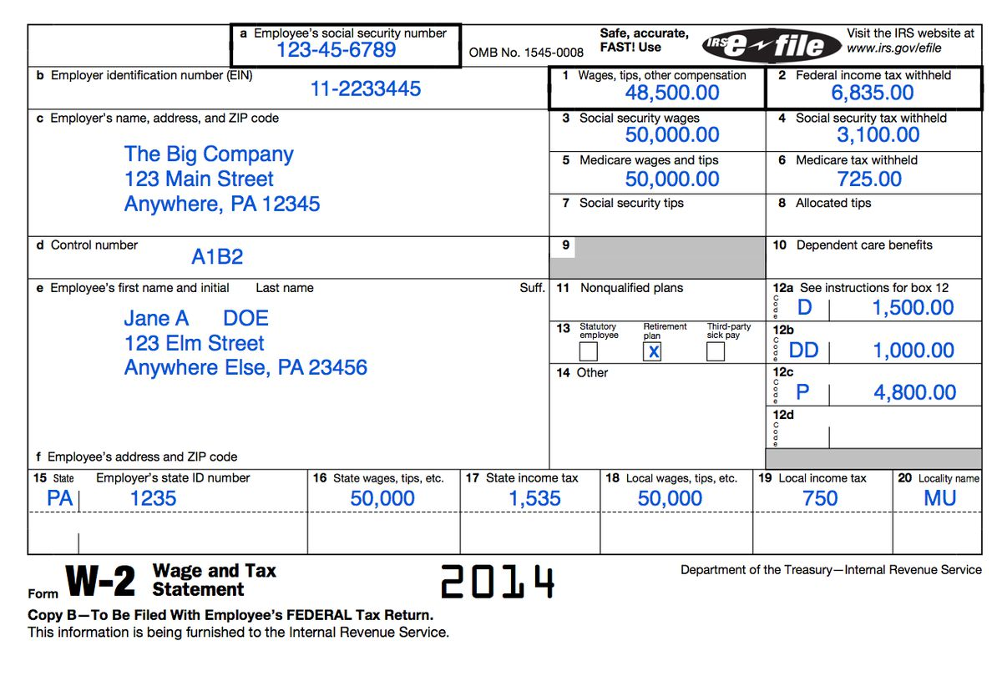

**Example W2 Form**

rm

Which total income amount is used for determining your Federal Income taxes?

What Is the total amount that was withheld from this sample for Federal, payroll, and stated taxes?

Lesson 5 - 2 – Work Laws

Objectives:

* Understand Employment Laws Protecting Employees
* Understand Laws that prohibit Discrimination of employees

Employment Laws:

|  |  |
| --- | --- |
| Law & Definition | Key Facts: |
|  |  |
|  |  |
|  |  |
|  |  |
|  |  |
|  |  |

|  |  |
| --- | --- |
| Law & Definition | Key Facts |
|  |  |
|  |  |
|  |  |
|  |  |
|  |  |